A Hand pump system

( kinematic diagram )

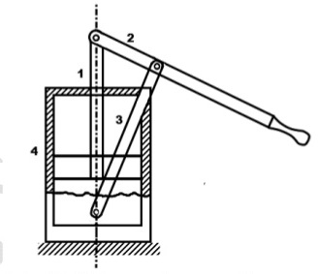

THE JOINTS:

* The connection of the fulcrum with the handle
* The handle and the piston
* The piston and the slider
* The fulcrum and the slider

The links:

* The handle
* The piston
* The slider
* The fulcrum

four-link system.

inversion of a double slider crank Mechanism.